***Living, Non-living or Dead***

Name: ____________________

Complete the table below showing the characteristics of the three sunflowers.

|  |  |  |  |  |  |  |
| --- | --- | --- | --- | --- | --- | --- |
| **Characteristic** | Image result for sunflowerSunflower | Image result for solar dancing sunflowerDancing sunflower | Image result for sunflower oilSunflower cooking oil | Paper | Fire | Tree |
| **Moves** by themselves | √ | √ | X | X | √ | √ |
| **Respond** to changes in their environment | √ | √ | X | X | √ | √ |
| **Grow** as they get older | √ | X | X | X | X | √ |
| **Reproduce** to make new individuals | √ | X | X | X | √ | √ |
| **Excretes** waste products | √ | X | X | X | √ | √ |
| **Exchange gases** with their environment | √ | X | X | X | √ | √ |
| **Nutrition** from food and water | √ | X | X | X | X | √ |

1. Which of the three sunflowers is non-living? What characteristics does it have?

**The dancing sunflower is non-living. It can move and respond to changes in its environment but foes not have all 7 characteristics. It is made from metal and plastic which never had all 7 characteristics.**

1. Which of the three sunflowers is dead? Which characteristics does it have?

**The sunflower cooking oil is dead. It has none of the 7 characteristics. It is made from sunflowers which once had all 7 characteristics.**

1. Which characteristics does the living sunflower have?

**The living sunflower has all 7 characteristics.**

1. Put headings of paper, fire and tree in the three blank columns of the table and then fill in the table.
2. Out of the paper, fire and tree, which is non-living? Why?

**The fire is non-living. It shows most of the 7 characteristics but not all. It never had all 7 characteristics.**

1. Which of the three is dead? Explain why.

**The paper is dead. It has none of the 7 characteristics. It is made from trees which once had all 7 characteristics.**

1. Which of the characteristics does the living thing have which the non-living thing does not?

**The living thing can grow, without returning to its original size. The tree can drink but the fire cannot.**

Characteristics of Living Things

The seven characteristics of living things are listed below. For each characteristic copy the statements from the box that help describe it. Two have been done for you.

1. **Move**
   * **Running**
   * **Crawling**
   * 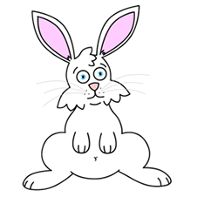 **Jumping**
   * **Walking**
2. **Respond**
   * **Taste**
   * **Hearing**
   * **Smell**
   * **Sight**
   * **Touch**
   * **Hot and cold**
3. **Grow**
   * **Getting bigger**
   * **Growing taller**
4. **Reproduce**
   * **Producing babies**
   * **Fertilisation**
5. **Excrete**
   * **Waste materials**
   * **Faeces**
   * **Urine**
   * **Sweating**
6. **Exchange gases**
   * **Carbon dioxide**
   * **Breathing in**
   * **Oxygen**
   * **Lungs**
7. **Nutrition**
   * **Minerals**
   * **Fibre**
   * **Eating food**
   * **Protein**
   * **Carbohydrate**
   * **Fats**
   * **Water**
   * 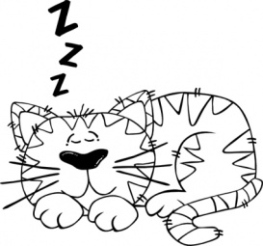 **Vitamins**

**Statements**

|  |  |  |
| --- | --- | --- |
| Running | Waste materials | Fertilisation |
| Carbon dioxide | Breathing in | Crawling |
| Getting bigger | Jumping | Sight |
| Taste | Carbohydrate | Vitamins |
| Minerals | Smell | Walking |
| Producing babies | Faeces | Hot and cold |
| Hearing | Touch | Sweating |
| Fibre | Fats | Oxygen |
| Eating food | Urine | Water |
| Protein | Growing taller | Lungs |

Cross off each statement as you use them.